**Regulatory Science Tool: Hemolysis dataset for validating computational fluid dynamic (CFD) simulation through generalized cardiovascular medical device geometries**

# Introduction

The tool provides validation hemolysis data obtained from inter-laboratory bench experiments within generic and simplified i) nozzle and ii) blood pump geometries that are common in cardiovascular devices.

Modelers can use the validation data to perform early-stage validation of their computational fluid dynamics (CFD) model of hemolysis before performing any device-specific verification, validation, and credibility assessment.

# Idealized device geometries

The two models were designed to provide flow characteristics which are representative of those in medical devices (e.g., laminar, transitional, and turbulent flows; gradual and sudden changes in flow areas; flows around rotating components). For the first study, a bidirectional nozzle model was created in which the flow diameter changed either suddenly or gradually.

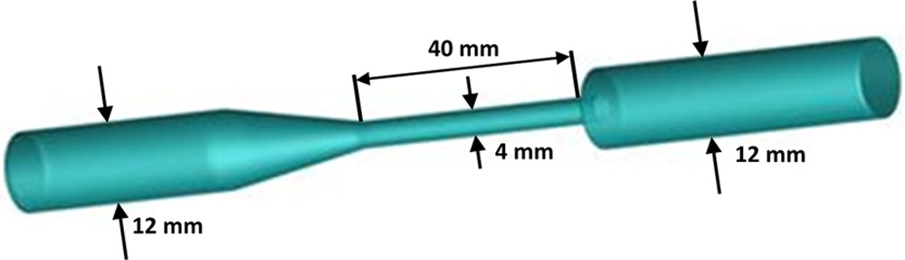

**Figure 1: FDA benchmark nozzle model with internal diameters and nozzle throat length identified.**

The second benchmark model was a centrifugal blood pump designed to have simple geometrical features and to operate over a wide range of flow and pressure conditions (Figure 2). The acrylic rotor (5.2 cm in diameter) had four filleted blades (3 mm tall and 3 mm wide) orthogonally positioned on a 4 mm thick rotor base, attached to a stainless steel shaft (3.2 mm in diameter). The shaft was sealed against blood leakage by using two spring-loaded, polymer-filled PTFE seals (Bal Seal Engineering, Foothill Ranch, CA) and grease (Molykote 111, Dow Corning, Midland, MI) recessed within the rear housing.

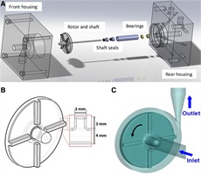

**Figure2: A**: Assembly drawing for FDA benchmark pump model. **B**: Enlargement of rotor showing dimensions of rounded blade edges. **C**: Computer model of pump.

Details of the Nozzle geometry and CAD files can be obtained [here](https://github.com/OSEL-DAM/CFD-and-Blood-Damage-Benchmarks/tree/main/Nozzle)

Details of the pump geometry, CAD files, and flow conditions can be obtained [here](https://github.com/OSEL-DAM/CFD-and-Blood-Damage-Benchmarks/blob/main/Blood%20Pump/Blood_Pump_Instructions.zip)

# Flow conditions

Flow parameters in the nozzle model for the three hemolysis test conditions are provided below

|  |  | **Sudden-Contraction Inlet 5 L/min (n = 26)** | **Gradual Cone Inlet 6 L/min (n = 26)** | **Sudden-Contraction Inlet 6 L/min (n = 36)** |
| --- | --- | --- | --- | --- |
| Measured Flow Rate (L/min) |  | 5.05 ± 0.12 | 5.94 ± 0.14 | 6.07 ± 0.08 |
| Pressure Drop Across Nozzle Model (mmHg) |  | 217 ± 15 | 309 ± 22 | 297 ± 15 |
| Pump Speed (rpm) |  | 3420 ± 70 | 4020 ± 110 | 3970 ± 60 |
| Reynolds Number in Nozzle Throat |  | 6650 ± 570 | 7860 ± 640 | 8020 ± 670 |
| Reynolds Number in ½″ ID Tubing |  | 2220± 190 | 2630± 210 | 2670± 220 |

**Table 1: Nozzle flow conditions for hemolysis testing. Values are shown as mean ± SD for three laboratories combined.**

Flow parameters for the pump model for are provided below

| **Condition #** | **Flow rate (L/min)** | **Pump speed (rpm)** | **Reynolds number (Re)** | **Flow coefficient (**Φ**)** |
| --- | --- | --- | --- | --- |
| 1 | 2.5 | 2500 | 209,338 | 0.00113 |
| 2 | 2.5 | 3500 | 293,073 | 0.00081 |
| 3 | 4.5 | 3500 | 293,073 | 0.00146 |
| 4 | 6.0 | 2500 | 209,338 | 0.00272 |
| 5 | 6.0 | 3500 | 293,073 | 0.00194 |
| 6 | 7.0 | 3500 | 293,073 | 0.00226 |

**Table 2: Blood pump flow conditions**

|  |  |
| --- | --- |
| Details | References |
| Geometric details about the devices | <https://www.fda.gov/medical-devices/science-and-research-medical-devices/benchmark-dataset-validating-computational-fluid-dynamic-cfd-simulation-blood-flow-through> |
| Flow conditions | 1. Nozzle: Table 1 in Herbertson et al. 2015, [10.1111/aor.12368](https://www.ncbi.nlm.nih.gov/pmc/articles/PMC4381842/) 2. Blood pump: Table 1 in Ponnaluri et al. 2022, [10.1007/s10439-022-03105-w](https://pubmed.ncbi.nlm.nih.gov/36401112/) |
| Hemolysis data | 1. Nozzle: Figures 3-5 in Herbertson et al. 2015, [10.1111/aor.12368](https://www.ncbi.nlm.nih.gov/pmc/articles/PMC4381842/) 2. Blood pump: Figure 11 in Ponnaluri et al. 2022, [10.1007/s10439-022-03105-w](https://pubmed.ncbi.nlm.nih.gov/36401112/) |

**Table 3: Additional details about the hemolysis data**

# Hemolysis data

## FDA Nozzle

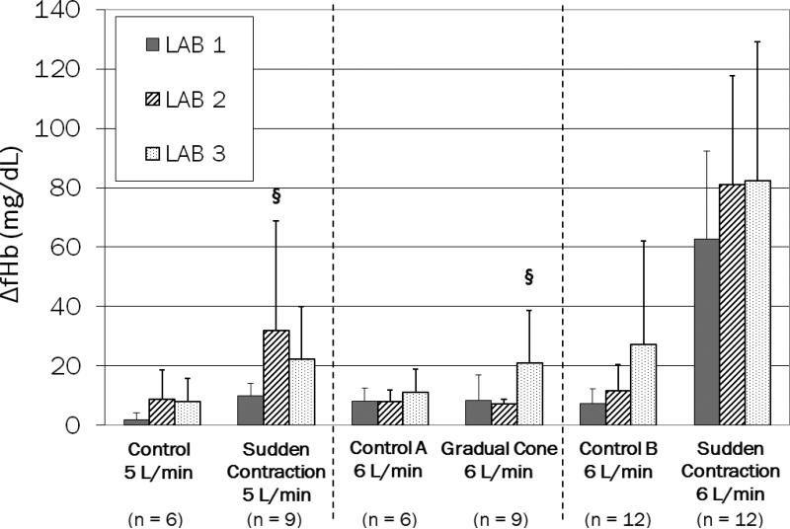

Figure 3: Change in plasma free hemoglobin concentration for bovine blood after 120 min of testing in nozzle and control conditions for three laboratories. Values are shown as mean ± SD for each laboratory, and the number of replicates per lab (*n*) is indicated for each test condition. § A single outlier was present and included in the specified data set

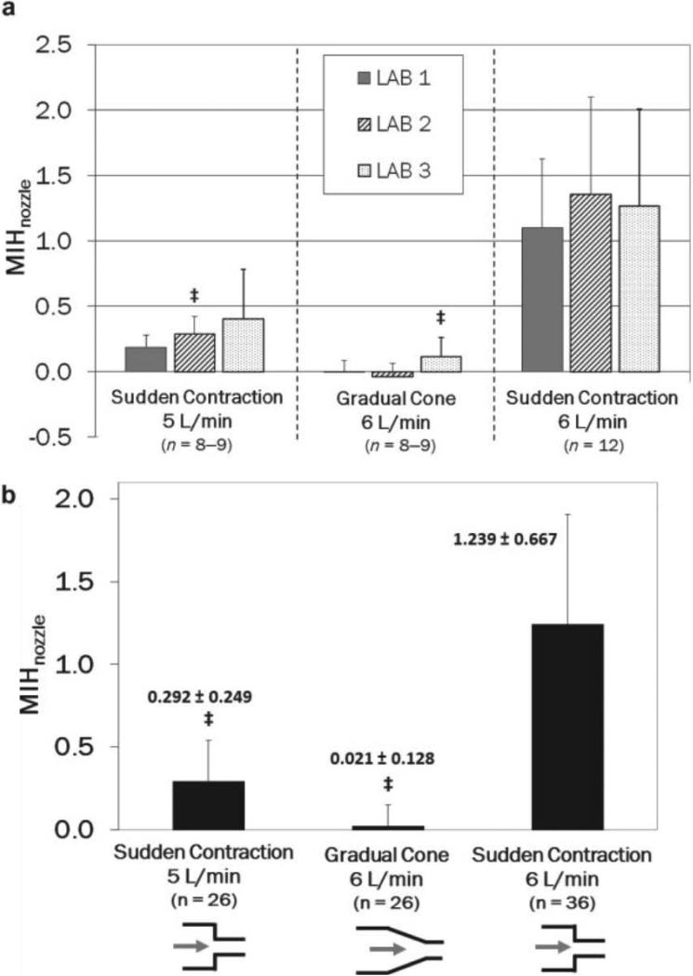

Figure 4: MIH values for the three nozzle test conditions after subtraction of the control loop MIH values (A) for each laboratory and (B) averaged for the three laboratories. ‡A single outlier was removed from the specified data set (n = total number of replicates).

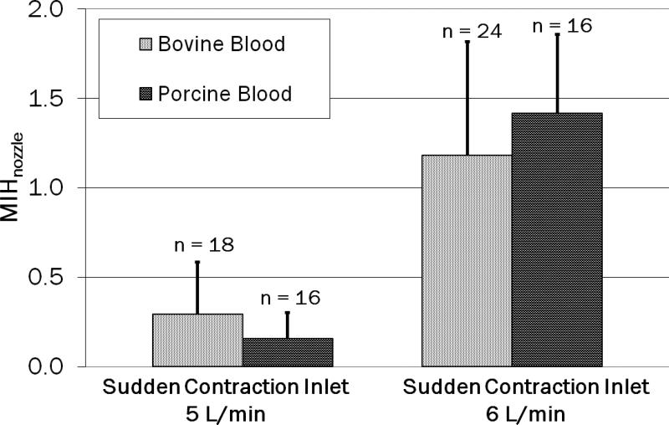

Figure 5: Comparison of the MIH between bovine and porcine blood for two nozzle test conditions after subtraction of the control loop MIH values at two laboratories. Values are shown as mean ± SD (n = total number of replicates per test condition).

## FDA Blood Pump

Hemolysis data for the blood pump are provided [here](https://link.springer.com/article/10.1007/s10439-022-03105-w/figures/11).